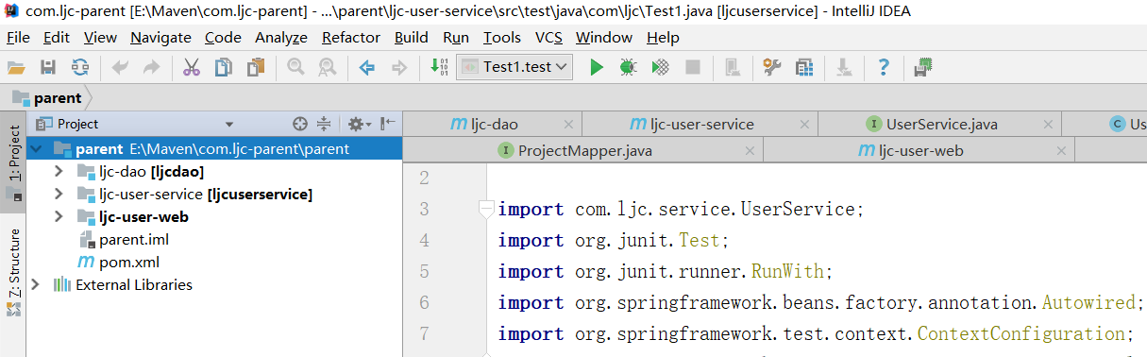

首先要有父类模块 这个工程是空工程 parent是java的 它自动生成了src 把他给删掉

然后有dao/持久层 里面有实体类跟mapper

其实还有service 服务层 里面写接口和实现类

还有web层 web层暂时不知道干嘛的 反正放了jsp

然后就是配置问题了

**首先是parent的pom.xml 不太明白啥意思 先复制里面的内容吧**

*<?***xml version="1.0" encoding="UTF-8"***?>*<**project xmlns="http://maven.apache.org/POM/4.0.0" xmlns:xsi="http://www.w3.org/2001/XMLSchema-instance"  
 xsi:schemaLocation="http://maven.apache.org/POM/4.0.0 http://maven.apache.org/xsd/maven-4.0.0.xsd"**>  
 <**modelVersion**>4.0.0</**modelVersion**>  
  
 <**groupId**>com.ljc</**groupId**>  
 <**artifactId**>parent</**artifactId**>  
 <**version**>1.0-SNAPSHOT</**version**>  
 *<!--pom打包方式：表明此模块为父模块-->* <**packaging**>pom</**packaging**>  
  
 *<!--表名ych-parent有2个子模块-->* <**modules**>  
 <**module**>ljc-dao</**module**>  
 <**module**>ljc-user-web</**module**>  
 *<!-- <module>ljc-common</module>-->* <**module**>ljc-user-service</**module**>  
 <**module**>ljc-user-web</**module**>  
 </**modules**>  
  
  
  
 <**name**>parent Maven Webapp</**name**>  
 *<!--* ***FIXME change it to the project's website*** *-->* <**url**>http://www.example.com</**url**>  
  
 <**properties**>  
 <**project.build.sourceEncoding**>UTF-8</**project.build.sourceEncoding**>  
 <**maven.compiler.source**>1.7</**maven.compiler.source**>  
 <**maven.compiler.target**>1.7</**maven.compiler.target**>  
 <**mybatis.version**>3.4.6</**mybatis.version**>  
 <**junit.version**>4.12</**junit.version**>  
 <**spring.version**>5.0.14.RELEASE</**spring.version**>  
 </**properties**>  
 *<!--1,公共的依赖：日志，单元测试-->* <**dependencies**>  
 *<!--日志门面：门面模式-->* <**dependency**>  
 <**groupId**>org.slf4j</**groupId**>  
 <**artifactId**>slf4j-api</**artifactId**>  
 <**version**>1.7.26</**version**>  
 </**dependency**>  
  
 <**dependency**>  
 *<!--日志的实现-->* <**groupId**>ch.qos.logback</**groupId**>  
 <**artifactId**>logback-classic</**artifactId**>  
 <**version**>1.2.3</**version**>  
 </**dependency**>  
  
 <**dependency**>  
 <**groupId**>org.springframework</**groupId**>  
 <**artifactId**>spring-test</**artifactId**>  
 <**version**>5.0.14.RELEASE</**version**>  
 </**dependency**>  
  
 </**dependencies**>  
  
 *<!--管理模块-->  
 <!--2,非公共的依赖：版本管理，父模块不会关联依赖-->* <**dependencyManagement**>  
 <**dependencies**>  
  
 <**dependency**>  
 <**groupId**>junit</**groupId**>  
 <**artifactId**>junit</**artifactId**>  
 <**version**>${junit.version}</**version**>  
 <**scope**>test</**scope**>  
 </**dependency**>  
  
 *<!--mybatis start-->  
 <!-- https://mvnrepository.com/artifact/org.mybatis/mybatis -->* <**dependency**>  
 <**groupId**>org.mybatis</**groupId**>  
 <**artifactId**>mybatis</**artifactId**>  
 <**version**>${mybatis.version}</**version**>  
 </**dependency**>  
  
 *<!--mybatis-spring-->  
  
 <!-- https://mvnrepository.com/artifact/org.mybatis/mybatis-spring -->* <**dependency**>  
 <**groupId**>org.mybatis</**groupId**>  
 <**artifactId**>mybatis-spring</**artifactId**>  
 <**version**>1.3.2</**version**>  
 </**dependency**>  
  
 *<!--mbg-->  
 <!-- https://mvnrepository.com/artifact/org.mybatis.generator/mybatis-generator-core -->* <**dependency**>  
 <**groupId**>org.mybatis.generator</**groupId**>  
 <**artifactId**>mybatis-generator-core</**artifactId**>  
 <**version**>1.3.7</**version**>  
 </**dependency**>  
  
 *<!--pageHelper-->  
 <!-- https://mvnrepository.com/artifact/com.github.pagehelper/pagehelper -->* <**dependency**>  
 <**groupId**>com.github.pagehelper</**groupId**>  
 <**artifactId**>pagehelper</**artifactId**>  
 <**version**>5.1.10</**version**>  
 </**dependency**>  
  
 *<!-- https://mvnrepository.com/artifact/commons-dbcp/commons-dbcp -->* <**dependency**>  
 <**groupId**>commons-dbcp</**groupId**>  
 <**artifactId**>commons-dbcp</**artifactId**>  
 <**version**>1.4</**version**>  
 </**dependency**>  
  
  
 *<!--mybatis end-->  
  
  
 <!--mysql驱动-->  
 <!-- https://mvnrepository.com/artifact/mysql/mysql-connector-java -->* <**dependency**>  
 <**groupId**>mysql</**groupId**>  
 <**artifactId**>mysql-connector-java</**artifactId**>  
 <**version**>5.1.48</**version**>  
 </**dependency**>  
  
 *<!--spring配置开始-->  
 <!-- https://mvnrepository.com/artifact/org.springframework/spring-context -->* <**dependency**>  
 <**groupId**>org.springframework</**groupId**>  
 <**artifactId**>spring-context</**artifactId**>  
 <**version**>${spring.version}</**version**>  
 </**dependency**>  
  
 *<!-- https://mvnrepository.com/artifact/org.springframework/spring-orm -->* <**dependency**>  
 <**groupId**>org.springframework</**groupId**>  
 <**artifactId**>spring-orm</**artifactId**>  
 <**version**>${spring.version}</**version**>  
 </**dependency**>  
 *<!-- https://mvnrepository.com/artifact/org.springframework/spring-jdbc -->* <**dependency**>  
 <**groupId**>org.springframework</**groupId**>  
 <**artifactId**>spring-jdbc</**artifactId**>  
 <**version**>${spring.version}</**version**>  
 </**dependency**>  
  
 </**dependencies**>  
  
 </**dependencyManagement**>  
  
 <**build**>  
 <**finalName**>parent</**finalName**>  
 <**pluginManagement**>*<!-- lock down plugins versions to avoid using Maven defaults (may be moved to parent pom) -->* <**plugins**>  
 <**plugin**>  
 <**artifactId**>maven-clean-plugin</**artifactId**>  
 <**version**>3.1.0</**version**>  
 </**plugin**>  
 *<!-- see http://maven.apache.org/ref/current/maven-core/default-bindings.html#Plugin_bindings_for_war_packaging -->* <**plugin**>  
 <**artifactId**>maven-resources-plugin</**artifactId**>  
 <**version**>3.0.2</**version**>  
 </**plugin**>  
 <**plugin**>  
 <**artifactId**>maven-compiler-plugin</**artifactId**>  
 <**version**>3.8.0</**version**>  
 </**plugin**>  
 <**plugin**>  
 <**artifactId**>maven-surefire-plugin</**artifactId**>  
 <**version**>2.22.1</**version**>  
 </**plugin**>  
 <**plugin**>  
 <**artifactId**>maven-war-plugin</**artifactId**>  
 <**version**>3.2.2</**version**>  
 </**plugin**>  
 <**plugin**>  
 <**artifactId**>maven-install-plugin</**artifactId**>  
 <**version**>2.5.2</**version**>  
 </**plugin**>  
 <**plugin**>  
 <**artifactId**>maven-deploy-plugin</**artifactId**>  
 <**version**>2.8.2</**version**>  
 </**plugin**>  
 </**plugins**>  
 </**pluginManagement**>  
 </**build**>  
</**project**>

**然后是dao层的pom配置**

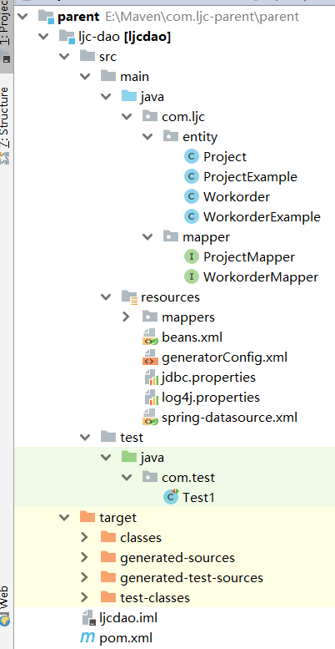

记得测试一下这个

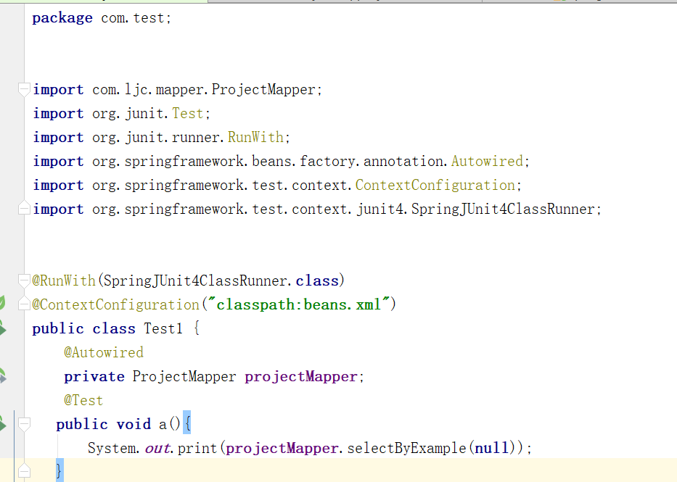

POM.xml配置

*<?***xml version="1.0" encoding="UTF-8"***?>*<**project xmlns="http://maven.apache.org/POM/4.0.0"  
 xmlns:xsi="http://www.w3.org/2001/XMLSchema-instance"  
 xsi:schemaLocation="http://maven.apache.org/POM/4.0.0 http://maven.apache.org/xsd/maven-4.0.0.xsd"**>  
 *<!--与哪个模块有父子关系-->* <**parent**>  
 <**artifactId**>parent</**artifactId**>  
 <**groupId**>com.ljc</**groupId**>  
 <**version**>1.0-SNAPSHOT</**version**>  
 </**parent**>  
 <**modelVersion**>4.0.0</**modelVersion**>  
 <**artifactId**>ljc-dao</**artifactId**>  
  
 <**dependencies**>  
  
 *<!--子模块不需要写版本，版本从父模块中继承过来-->* <**dependency**>  
 <**groupId**>junit</**groupId**>  
 <**artifactId**>junit</**artifactId**>  
 </**dependency**>  
  
 <**dependency**>  
 <**groupId**>org.springframework</**groupId**>  
 <**artifactId**>spring-orm</**artifactId**>  
 </**dependency**>  
 <**dependency**>  
 <**groupId**>org.springframework</**groupId**>  
 <**artifactId**>spring-jdbc</**artifactId**>  
 </**dependency**>  
 <**dependency**>  
 <**groupId**>org.springframework</**groupId**>  
 <**artifactId**>spring-context</**artifactId**>  
 </**dependency**>  
 <**dependency**>  
 <**groupId**>mysql</**groupId**>  
 <**artifactId**>mysql-connector-java</**artifactId**>  
 </**dependency**>  
  
 <**dependency**>  
 <**groupId**>org.mybatis</**groupId**>  
 <**artifactId**>mybatis</**artifactId**>  
 </**dependency**>  
  
 <**dependency**>  
 <**groupId**>org.mybatis</**groupId**>  
 <**artifactId**>mybatis-spring</**artifactId**>  
 </**dependency**>  
  
 <**dependency**>  
 <**groupId**>org.mybatis.generator</**groupId**>  
 <**artifactId**>mybatis-generator-core</**artifactId**>  
 </**dependency**>  
 <**dependency**>  
 <**groupId**>commons-dbcp</**groupId**>  
 <**artifactId**>commons-dbcp</**artifactId**>  
 </**dependency**>  
 <**dependency**>  
 <**groupId**>com.github.pagehelper</**groupId**>  
 <**artifactId**>pagehelper</**artifactId**>  
 </**dependency**>  
 </**dependencies**>  
 <**build**>  
 <**plugins**>  
 *<!--mbg插件-->* <**plugin**>  
 <**groupId**>org.mybatis.generator</**groupId**>  
 <**artifactId**>mybatis-generator-maven-plugin</**artifactId**>  
 <**version**>1.3.7</**version**>  
 </**plugin**>  
 </**plugins**>  
 </**build**>  
  
  
</**project**>

接下来是service 服务层

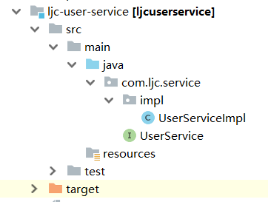

*<?***xml version="1.0" encoding="UTF-8"***?>*<**project xmlns="http://maven.apache.org/POM/4.0.0"  
 xmlns:xsi="http://www.w3.org/2001/XMLSchema-instance"  
 xsi:schemaLocation="http://maven.apache.org/POM/4.0.0 http://maven.apache.org/xsd/maven-4.0.0.xsd"**>  
 <**parent**>  
 <**artifactId**>parent</**artifactId**>  
 <**groupId**>com.ljc</**groupId**>  
 <**version**>1.0-SNAPSHOT</**version**>  
 </**parent**>  
 <**modelVersion**>4.0.0</**modelVersion**>  
  
 <**artifactId**>ljc-user-service</**artifactId**>  
  
 <**dependencies**>  
 <**dependency**>  
 <**groupId**>com.ljc</**groupId**>  
 <**artifactId**>ljc-dao</**artifactId**>  
 <**version**>1.0-SNAPSHOT</**version**>  
 </**dependency**>  
 <**dependency**>  
 <**groupId**>com.ljc</**groupId**>  
 <**artifactId**>ljc-dao</**artifactId**>  
 <**version**>1.0-SNAPSHOT</**version**>  
 </**dependency**>  
 <**dependency**>  
 <**groupId**>junit</**groupId**>  
 <**artifactId**>junit</**artifactId**>  
 </**dependency**>  
 <**dependency**>  
 <**groupId**>org.springframework</**groupId**>  
 <**artifactId**>spring-context</**artifactId**>  
 </**dependency**>  
 <**dependency**>  
 <**groupId**>com.github.pagehelper</**groupId**>  
 <**artifactId**>pagehelper</**artifactId**>  
 </**dependency**>  
  
 </**dependencies**>  
  
  
</**project**>

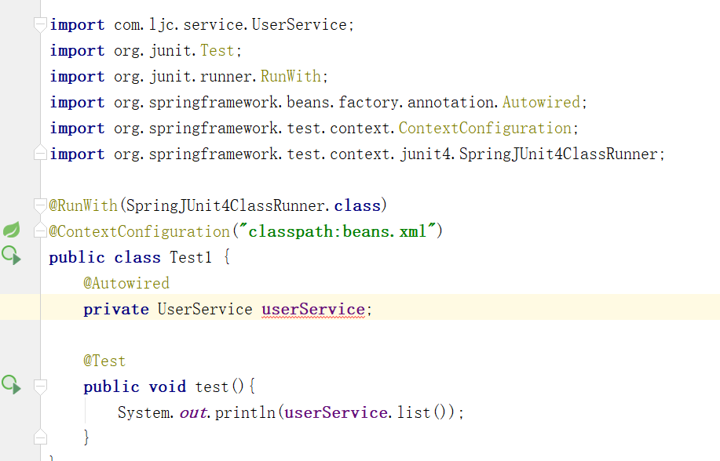

**最后就是web层了**

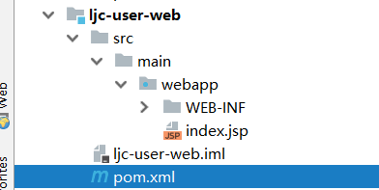

*<?***xml version="1.0" encoding="UTF-8"***?>*<**project xmlns="http://maven.apache.org/POM/4.0.0" xmlns:xsi="http://www.w3.org/2001/XMLSchema-instance"  
 xsi:schemaLocation="http://maven.apache.org/POM/4.0.0 http://maven.apache.org/xsd/maven-4.0.0.xsd"**>  
 <**parent**>  
 <**artifactId**>parent</**artifactId**>  
 <**groupId**>com.ljc</**groupId**>  
 <**version**>1.0-SNAPSHOT</**version**>  
 </**parent**>  
 <**modelVersion**>4.0.0</**modelVersion**>  
  
 <**artifactId**>ljc-user-web</**artifactId**>  
 <**packaging**>war</**packaging**>  
  
 <**name**>ljc-user-web Maven Webapp</**name**>  
 *<!--* ***FIXME change it to the project's website*** *-->* <**url**>http://www.example.com</**url**>  
  
 <**properties**>  
 <**project.build.sourceEncoding**>UTF-8</**project.build.sourceEncoding**>  
 <**maven.compiler.source**>1.7</**maven.compiler.source**>  
 <**maven.compiler.target**>1.7</**maven.compiler.target**>  
 </**properties**>  
  
 <**dependencies**>  
 <**dependency**>  
 <**groupId**>junit</**groupId**>  
 <**artifactId**>junit</**artifactId**>  
 <**version**>4.11</**version**>  
 <**scope**>test</**scope**>  
 </**dependency**>  
 </**dependencies**>  
  
 <**build**>  
 <**finalName**>ljc-user-web</**finalName**>  
 <**pluginManagement**>*<!-- lock down plugins versions to avoid using Maven defaults (may be moved to parent pom) -->* <**plugins**>  
 <**plugin**>  
 <**artifactId**>maven-clean-plugin</**artifactId**>  
 <**version**>3.1.0</**version**>  
 </**plugin**>  
 *<!-- see http://maven.apache.org/ref/current/maven-core/default-bindings.html#Plugin_bindings_for_war_packaging -->* <**plugin**>  
 <**artifactId**>maven-resources-plugin</**artifactId**>  
 <**version**>3.0.2</**version**>  
 </**plugin**>  
 <**plugin**>  
 <**artifactId**>maven-compiler-plugin</**artifactId**>  
 <**version**>3.8.0</**version**>  
 </**plugin**>  
 <**plugin**>  
 <**artifactId**>maven-surefire-plugin</**artifactId**>  
 <**version**>2.22.1</**version**>  
 </**plugin**>  
 <**plugin**>  
 <**artifactId**>maven-war-plugin</**artifactId**>  
 <**version**>3.2.2</**version**>  
 </**plugin**>  
 <**plugin**>  
 <**artifactId**>maven-install-plugin</**artifactId**>  
 <**version**>2.5.2</**version**>  
 </**plugin**>  
 <**plugin**>  
 <**artifactId**>maven-deploy-plugin</**artifactId**>  
 <**version**>2.8.2</**version**>  
 </**plugin**>  
 </**plugins**>  
 </**pluginManagement**>  
 </**build**>  
</**project**>